Project Design Phase-II
Data Flow Diagram & User Stories

Date | 31 January 2025
Team ID
Project Name | ServiceNow Incident Management Enhancement
Maximum Marks | 4 Marks

Data Flow Diagrams:
A Data Flow Diagram (DFD) is a traditional visual representation of the information flows within a system. A neat and clear DFD can depict the right amount of the system requirement graphically. It shows how data enters and leaves the system, what changes the information, and where data is stored.

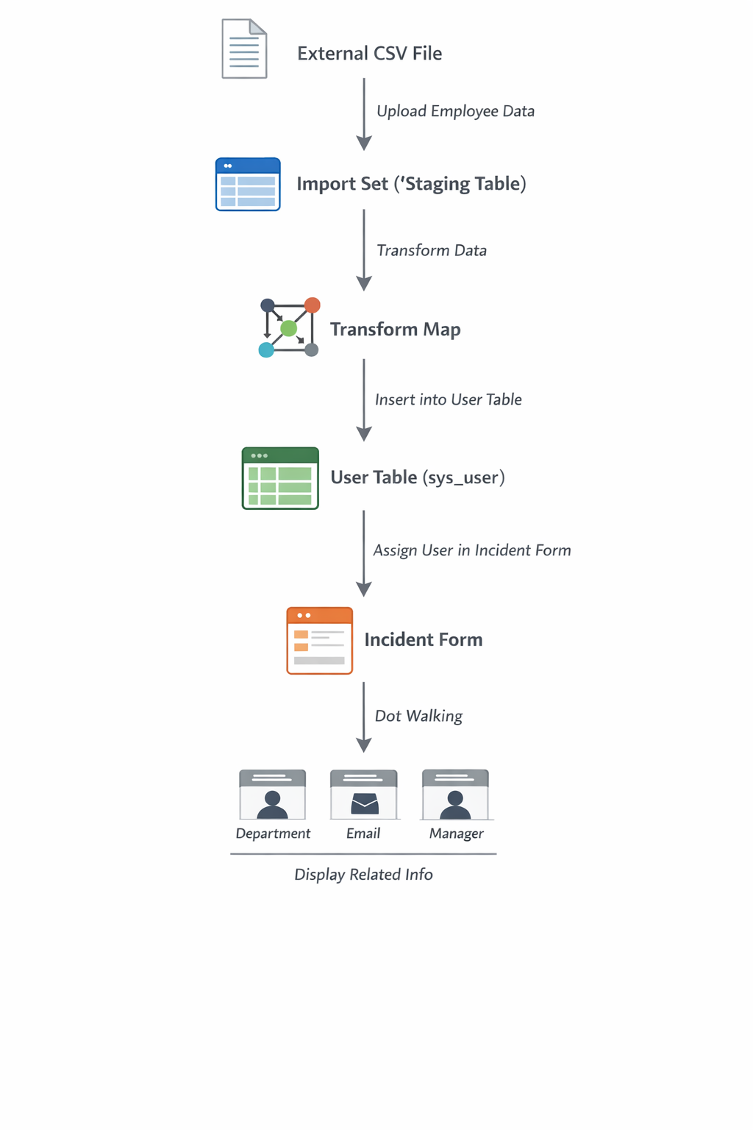

User Stories

IT Support Agent
User Type | Functional Requirement (Epic) | User Story Number | User Story / Task | Acceptance Criteria | Priority | Release
IT Support Agent | Incident Handling | USN-1 | As an agent, I can select a user in Assigned To field | User should appear in lookup and be selectable | High | Sprint-1
IT Support Agent | Data Visibility | USN-2 | As an agent, I can view department, email, and manager automatically | Fields auto-populate when user is selected | High | Sprint-1
IT Support Agent | Efficient Workflow | USN-3 | As an agent, I can access user data without opening multiple records | No manual navigation required | High | Sprint-1

